One reach Create INC:

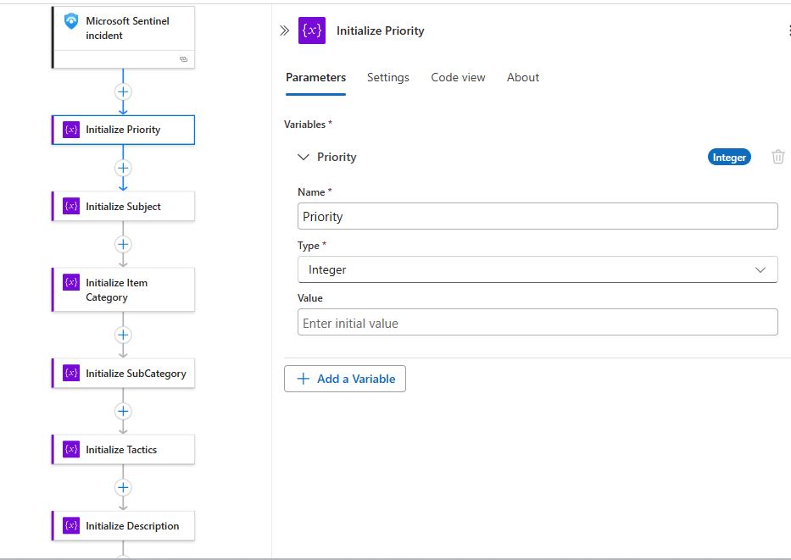

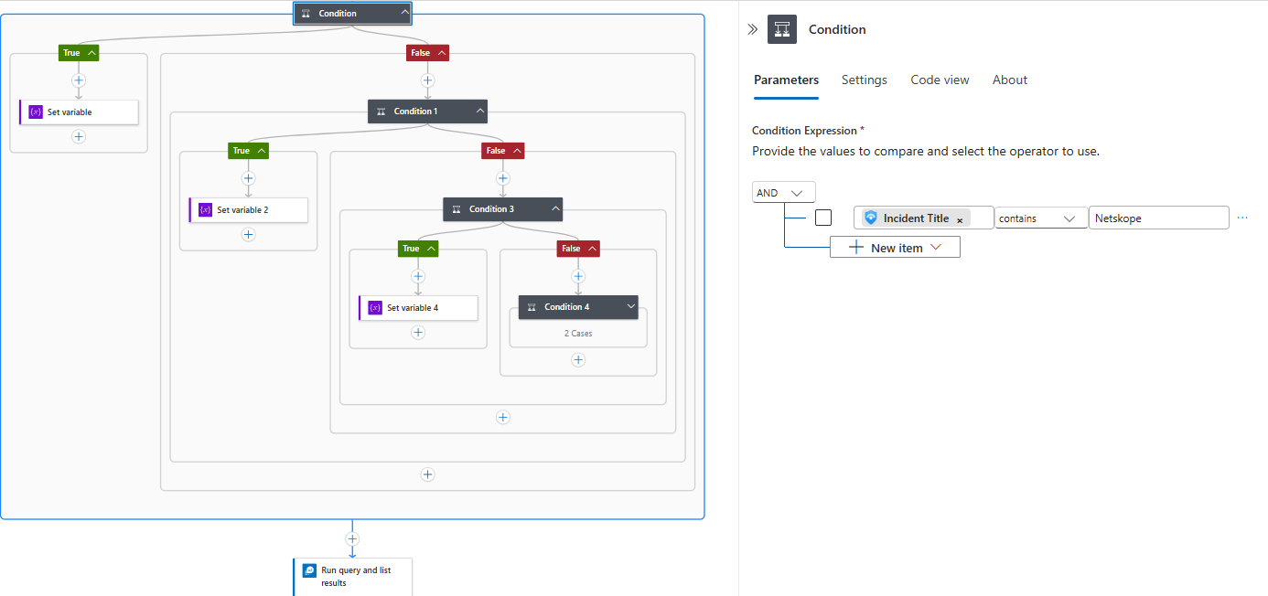

Same way apply infinite for loop whatever number of tools you have….

